Association

# Model

## Association

Covariates

* Pre-computed first 10 PC
* Sex
* Birth year
* Genotype measurement wells

Parameters

* White British



## Get Phenotypes and Covariates

|  |  |  |
| --- | --- | --- |
| **Description** | **Field ID** | **Column Number** |
| Standing Height | 50-1.0 | 82 |
| 40 PC | 22009 | 10004 – 10043 |
| Ethnicity | 21000 | 9786 |
| Sex | 22003 | 9997 |
| Birth Year | 34 | 25 |
| Genotype measurement batch | 22000 | 9996 |
| Genotype measurement plate | 22007 | 10002 |
| Genotype measurement well | 22008 | 10003 |

*6/1/2021 data columns in phenotype file are shifted to the right by 1



* IDs column



* Get column number based on Field ID



* Extract desired fields using column number



* Keep only white British from ethnicity data field
  + White British == 1001



* Concatenate covariates



* Remove rows with missing values



## Combine Results



## Scatter Plot and Correlation

* Plot the negative log10 p-values of Neale Lab and plink2 results to examine for errors
* Obtain correlation between Neale and plink2 p-value results



## Manhattan Plot

Code adapted from:

<https://piperwrites95180714.wordpress.com/2018/04/04/genome-wide-association-study-manhattan-plot-tutorial/>

<https://stackoverflow.com/questions/37463184/how-to-create-a-manhattan-plot-with-matplotlib-in-python>

* Manhattan plots show the neg log 10 p-values on a genomic scale. The skyscrapers represent clusters of SNPs in strong LD with each other. X axis is ordered by chromosome and chromosome position.

#!/usr/bin/env python3

# import packages

import matplotlib

matplotlib.use("Agg")

import numpy as np

import matplotlib.pyplot as plt

import pandas as pd

import os

# set working directory

os.chdir("/scratch1/08005/cz5959/Association_Height_50")

# DATAFRAME

# load file to dataframe

results_df = pd.read_csv("linear_results_all_chrom.height.glm.linear", sep="\t", usecols =['#CHROM','POS','P','ID'])

# drop rows with any column having null/missing data

results_df = results_df.dropna()

# sort by column then position; reset index

results_df = results_df.sort_values(['#CHROM', 'POS'])

results_df.reset_index(inplace=True, drop=True)

# change P column to float type

results_df['P'] = pd.to_numeric(results_df['P'])

# create column with negative log p value

results_df['NEG_LOG_P'] = -np.log10(results_df['P'])

# make chromosome column into type category

results_df['#CHROM'] = results_df['#CHROM'].astype('category')

# index; used for x axis; assume uniform SNP distrubtion across chromosome

results_df['index'] = range(len(results_df))

# group by chromosome

grouped_df = results_df.groupby(('#CHROM'))

#PLOT

fig = plt.figure(figsize=(16,6))

# axes of figure - 1row,1col,1idx

ax = fig.add_subplot(111)

colors = ['#466EA6','#7251B8']

x_labels = []

x_labels_pos = []

# create subplots for each chromosome (name = #CHROM)

for num, (name, group) in enumerate(grouped_df):

    ##### plot, x is index and y is neg log p ######

    group.plot(kind='scatter', x='index', y='NEG_LOG_P',color=colors[num % len(colors)], ax=ax, s=0.1, marker = '.')

    # name of chr

    x_labels.append(name)

    # tick marks; middle of group

    x_labels_pos.append((group['index'].iloc[-1] - (group['index'].iloc[-1] - group['index'].iloc[0])/2))

#line

ax.plot([0,len(results_df)],[5,5])

# figure labels

ax.set_xticks(x_labels_pos)

ax.set_xticklabels(x_labels)

ax.set_xlim([0, len(results_df)])

ax.set_ylim([0, 10])

ax.set_xlabel('Chromosome')

ax.set_title('Manhattan Plot')

# save as png

plt.tight_layout()

plt.savefig("manhattan_height.png")

## QQ Plot

* A QQ plot shows the deviation of observed p-values from the null hypothesis. In the null hypothesis, the SNPs are not associated with the trait, and follow a uniform distribution. The observed p values are ordered and plotted against the expected.
* If the observed deviates towards y-axis too early, it means that many significant p values are more significant than expected under the null, which is rare.

# Log

### 5/24/2021

* Why do I have multiple p-values for the same SNP in my gwas results?

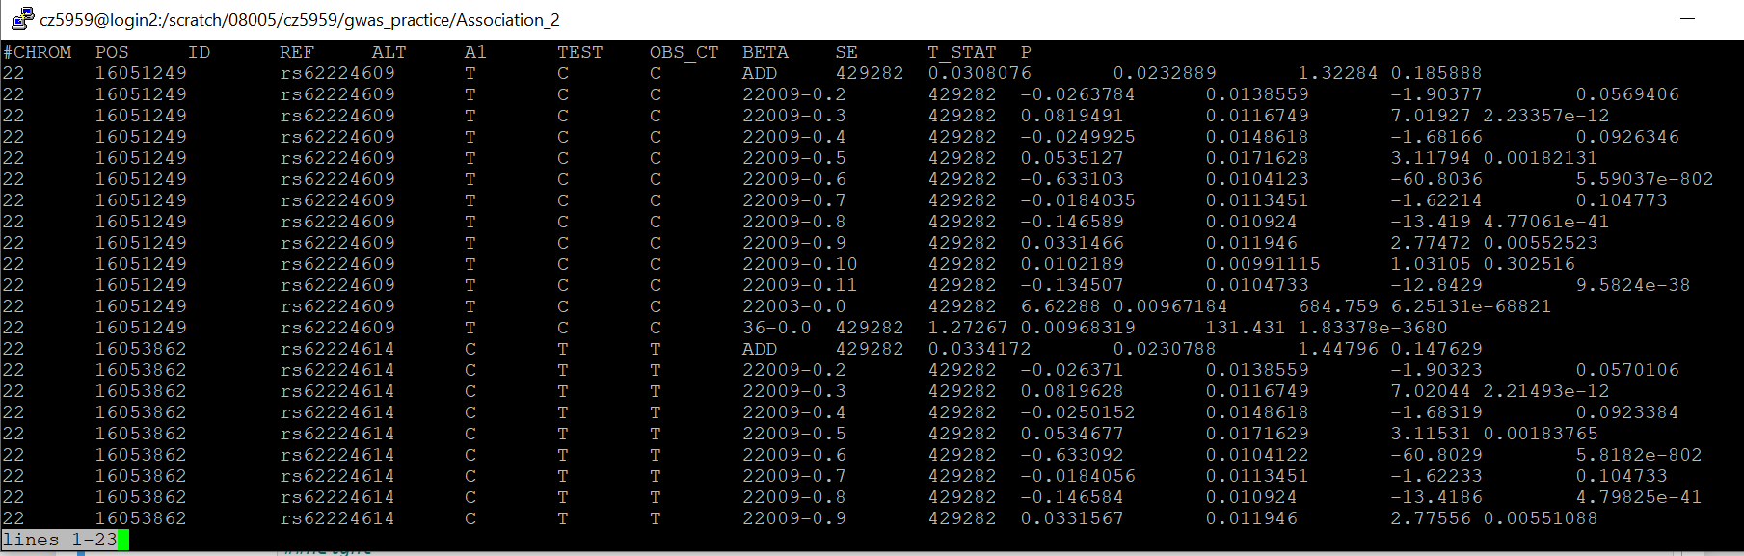

* + Plink2 default output file contains a line for each genotype column and each non-intercept covariate column
  + If not using information from covariate column, use ‘hide-covar’ modifier for –glm

### 5/25/2021

* Transfer files from ls5 to frontera
* Redo height gwas with ‘hide-covar’ modifier and combine the results
* Manhattan plot for height after hiding covariates

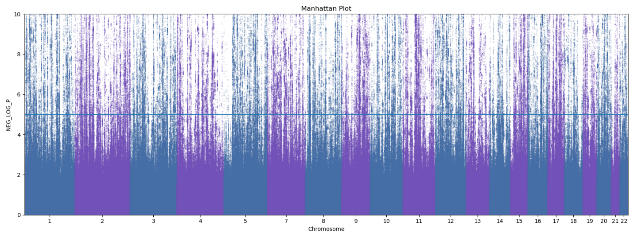

* Correlation between Neale and plink2 gwas results for height
  + Order of Correlations  
    plink and Neale: 0.708 ; rows = 132740  
    plink and own: 0.443 ; rows = 869  
    Neale and own: 0.319 ; rows = 860
  + I need more of my own P values to compare the p-values better. For plink and own, I used the 10 covariates, plus birth year and sex as covariates. Otherwise, the QC is the same for plink and own since I converted from the final QC file to the raw file
  + Neale Covariates: 1st 20 PCs + sex + age + age^2 + sexage + sexage2

### 5/26/2021

* Scatterplot of p-values for Neale and plink2 results of gwas for height

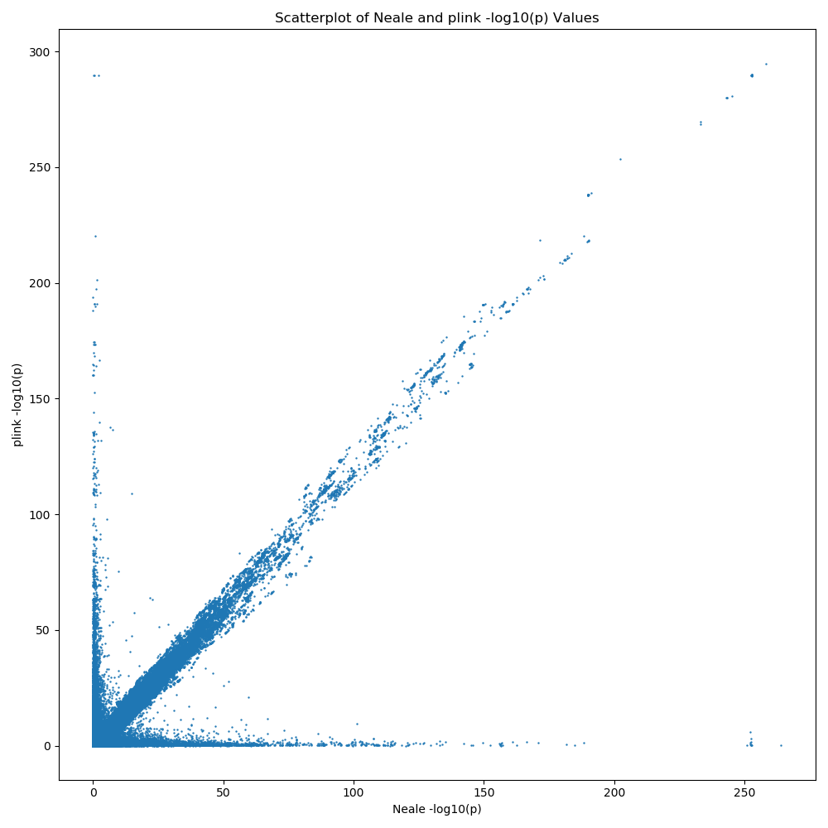

* + Clear diagonal line; plink2’s negative log10 p-values are consistently higher than Neale’s
    - Plink2 results come from QC with larger sample size
  + Two ‘prongs’ concentrated at the sides
* Histogram of chromosome frequencies of side prongs
  + Vertical prong

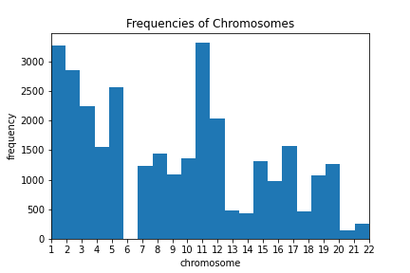

* + Horizontal prong

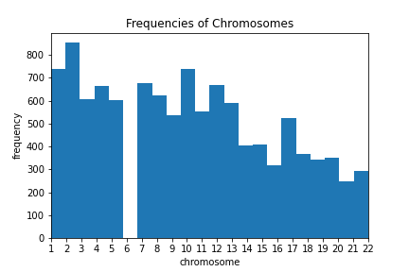

* Possible duplication when joining plink2 and Neale results, since joined on position, which is not unique
  + Join on combination of chromosome, position, ref and alt allele

5/27/2021

* 756 duplicated rows when checking variant

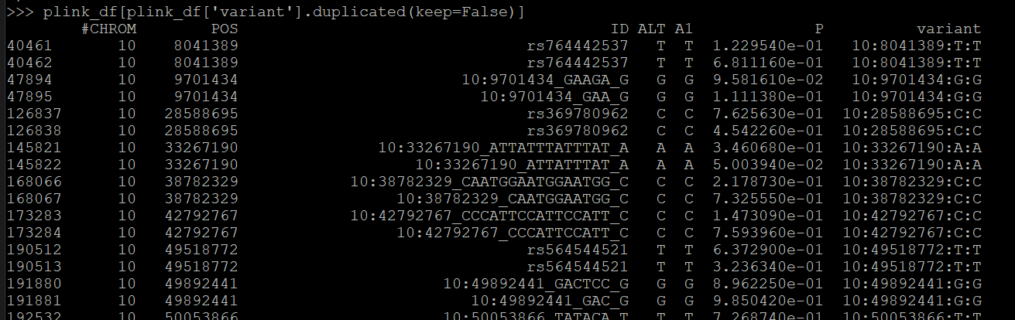

* 18943 duplicated rows when checking ID

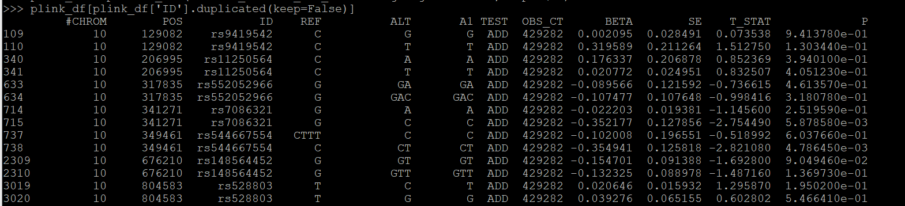

* Neale has no duplicated rows
* Remove duplicates and indels from QC
  + Duplicates likely to be indels or multiallelic SNPs
  + Indels signified by ID column <chr>:<position>:<REF ALLELE>:<ALT ALLELE>

### 6/1/2021

* Add genotype measurement batch, plate, and wells as covariates
  + Why: each study site might have specific preference/bias for calling allele which can drive significant associations between SNP and phenotype
* Error with new association



* + Only kept ‘genotype measurement batch out of the three genotype measurement options
* P